DATABASE SYSTEM EXAM

A.Y 2021/2022

Contents

Intro 2

GUI 4

CRUD Operations 9

INSERT OPEARTION 9

UPDATE OPERATION 10

DELETE OPERATION 11

Other operations 12

Fruit operations 12

INSERT Operation 12

UPDATE Operation 13

DELETE Operation 15

OFFER Operations 17

INSERT Operation 17

SWITCH TO CUSTOMER VIEW 18

SENSOR FRUIT Operations 22

Run application 30

# Intro

In this section we go throw all the possible operations of the system.

|  |  |
| --- | --- |
| TABLE NAME | OPERATIONS |
| RECIPE_TAB | * Insert Recipe * Update Recipe info * Delete Recipe * Read Recipes Info * Reset Form * Get info about one recipe |
| FRUIT_TAB | * Insert Fruit * Update Fruit info * Delete Fruit * Read Fruits Info * Reset Form * Get info about one fruit * Switch to customer view |
| FRUIT_RECIPE_TAB | * Insert Fruit-Recipe correlation * Update Fruit-Recipe correlation * Delete Fruit-Recipe correlation * Read Fruit-Recipe correlation * Reset Form * Get info about one Fruit-Recipe correlation |
| USER_TAB | * Insert User * Update User * Delete User * Read Users Info * Reset Form * Get info about one user |
| SENSOR_TAB | * Insert Sensor * Update Sensor info * Delete Sensor * Read Sensors Info * Reset Form * Get info about one sensor |

|  |  |
| --- | --- |
| TABLE NAME | OPERATIONS |
| FRUIT_SENSOR_TAB | * Insert Freshness entry * Update Freshness entry info * Delete Freshness entry * Read Freshness Entry Info * Reset Form * Get info about one Freshness entry |
| FRESHNESS_TAB | * Insert Freshness entry * Update Freshness entry info * Delete Freshness entry * Read Freshness Entry Info * Reset Form * Get info about one Freshness entry |
| OFFER_TAB | * Insert Offer * Update Offer info * Delete Offer * Read Offer Info * Reset Form * Get info about one Offer * Switch to customer view * Buy offer as customer |
| OFFER_USER_TAB | * Read Offer Info about customer purchases |
| ALLERGY_TAB | * Insert Allergy * Update Allergy entry info * Delete Allergy * Read Allergy Info * Reset Form * Get info about one Allergy |

## GUI

The graphical user interface was created by using Angular framework with python module Flask as backend.

The main screen is the following one:

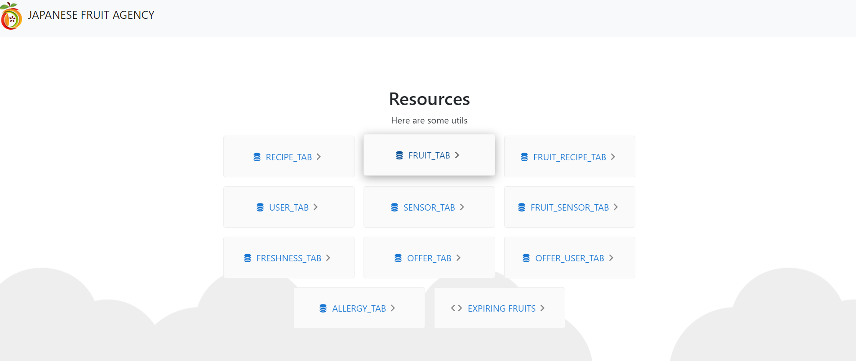

There are 11 cards, 10 for database table , and 1 for a custom operation .

Almost all sections are composed by two main components which are:

* A form for collect information
* A table for show information

The following table explore each section and give you all possible views:

|  |
| --- |
| RECIPE TAB |
| OPERATOR VIEW |

|  |
| --- |
| FRUIT TAB |
| OPERATOR VIEW    CUSTOMER VIEW |

|  |
| --- |
| FRUIT RECIPE TAB |
| CUSTOMER/OPERATOR VIEW |

|  |
| --- |
| USER TAB |
| OPERATOR VIEW |

|  |
| --- |
| SENSOR TAB |
| OPERATOR VIEW |

|  |
| --- |
| FRUIT SENSOR TAB |
| OPERATOR VIEW |

|  |
| --- |
| FRESHNESS TAB |
| OPERATOR VIEW |

|  |
| --- |
| OFFER TAB |
| OPERATOR VIEW    CUSTOMER VIEW |

|  |
| --- |
| OFFER USER TAB |
| OPERATOR VIEW |

|  |
| --- |
| EXPIRING FRUIT OPERATION |
| Show expiring fruits in the current day, one day, two days.  OPERATOR VIEW |

# CRUD Operations

The CRUD operations (Create, Read, Update, Delete) are performed in the same way for all the tables that can support them.

The following guide is an example of how to perform this operations on RECIPE table but the same procedure could be applied to all tables that allow CRUD operations.

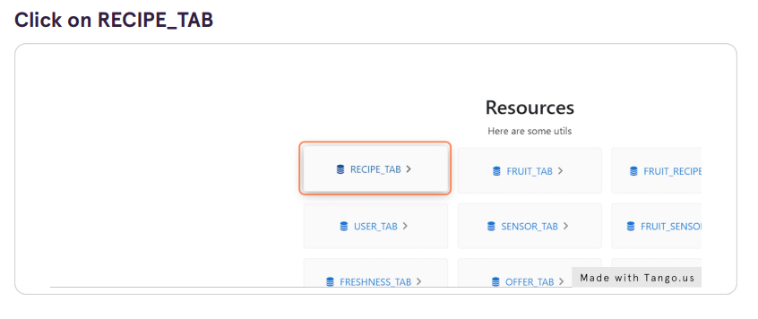

## INSERT OPEARTION

**Compile the form with new recipe info**



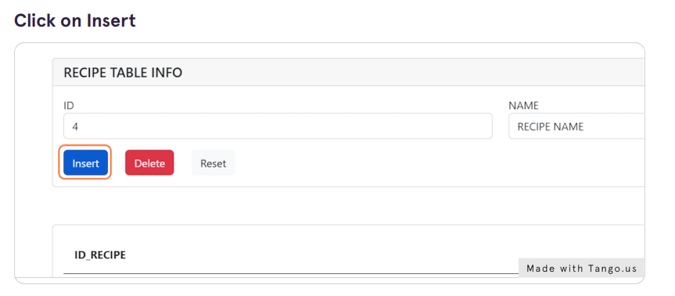

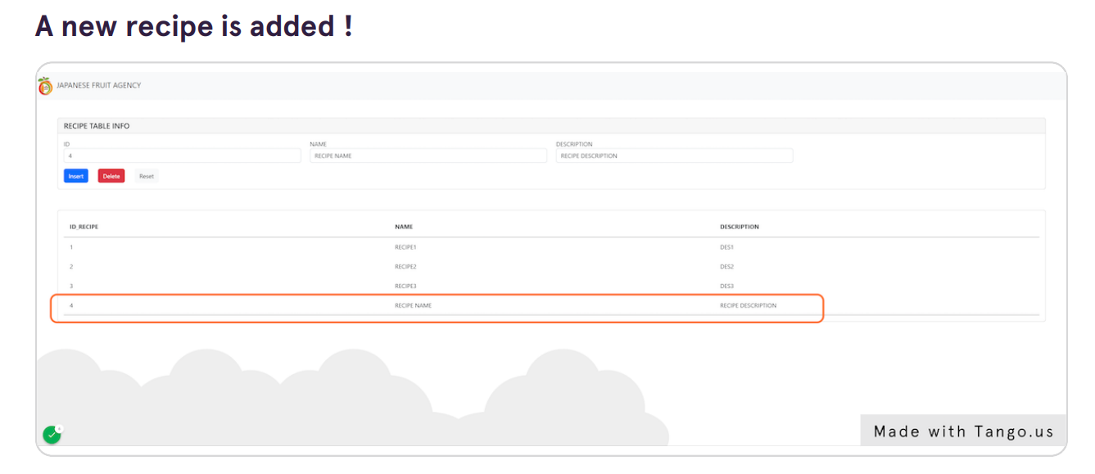

## UPDATE OPERATION

TIPS: You can click every element in the table and the form will automatically compiled with the record information

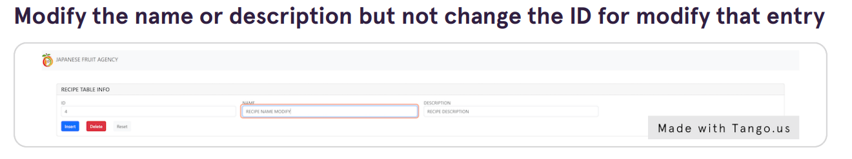

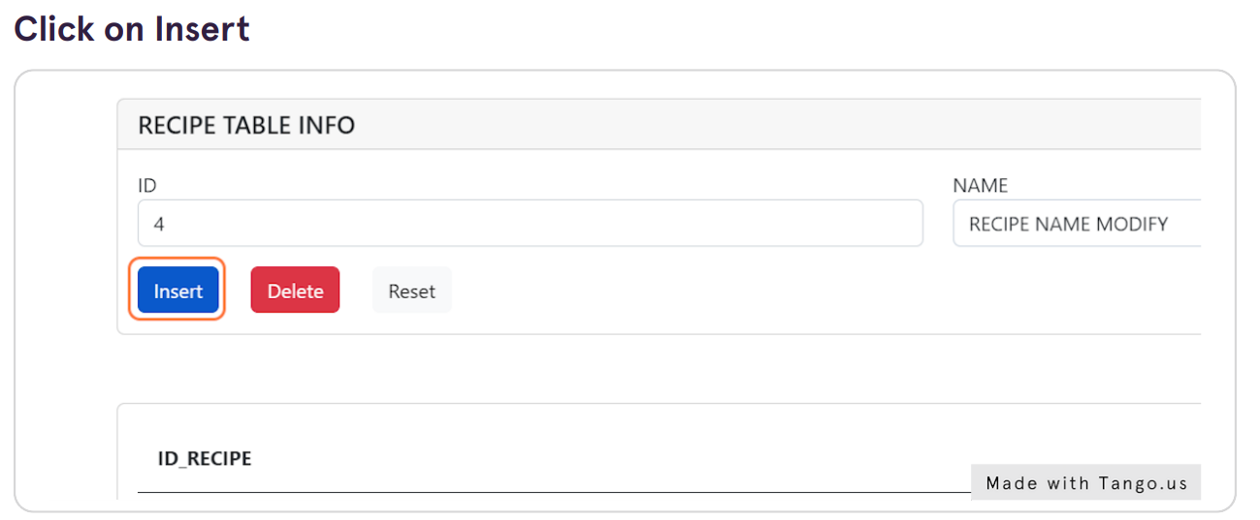

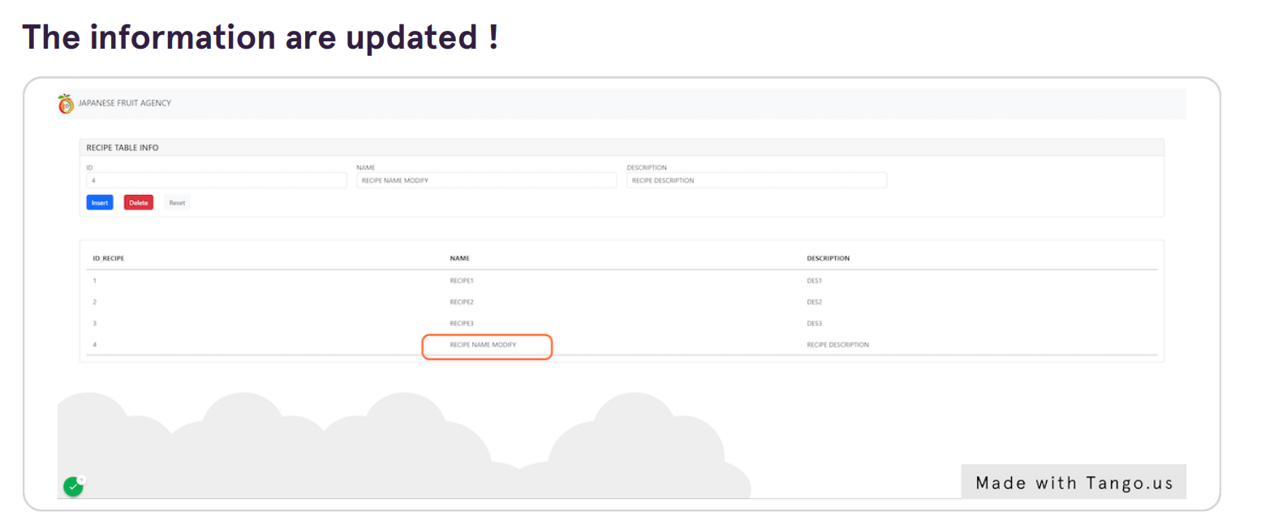

## DELETE OPERATION

TIPS: You can click every element in the table and the form will automatically compiled with the record information

Select one row to delete and the click to delete

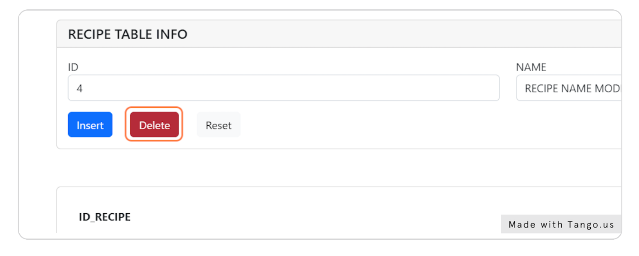

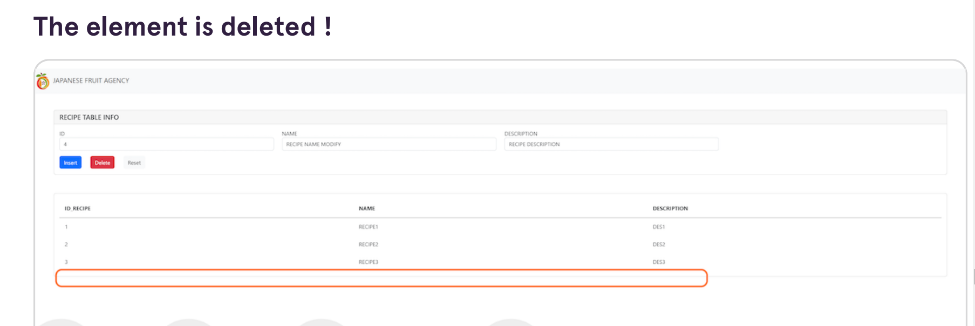

# Other operations

In this section we will analyze all the operations different from the CRUD operations listed in the previous section. These operations call for the execution of some triggers and require detailed investigation.

## Fruit operations

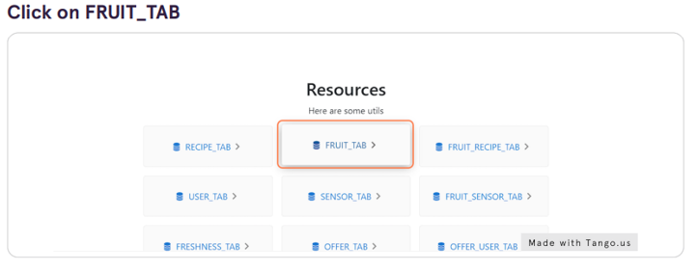

### INSERT Operation

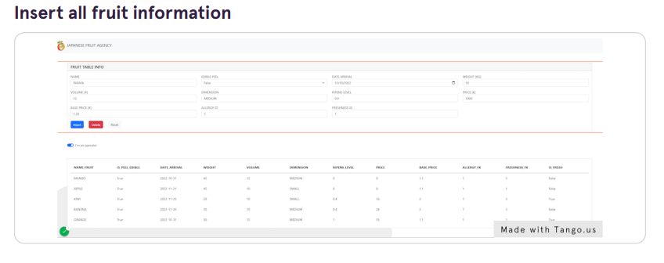

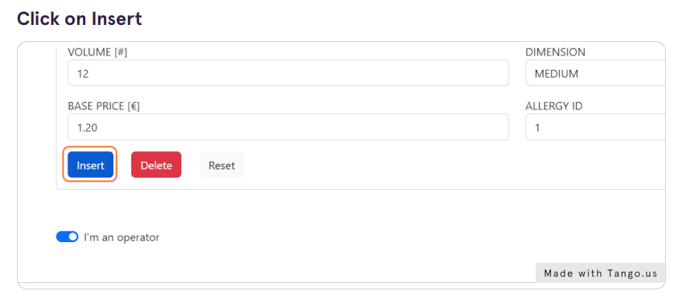

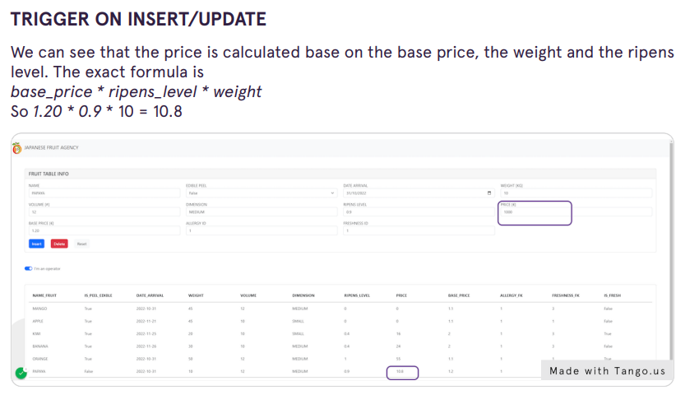

### UPDATE Operation



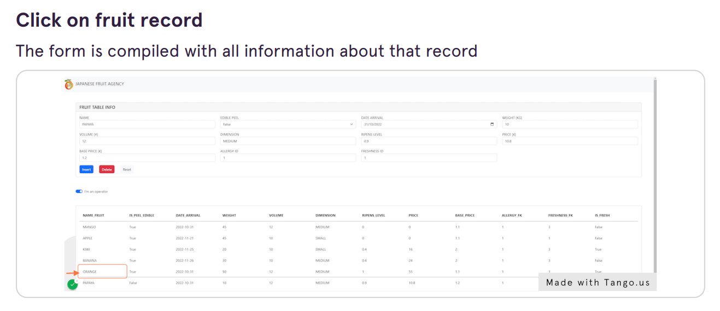

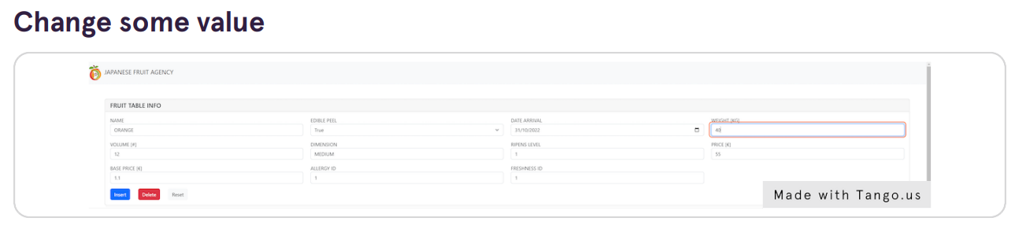

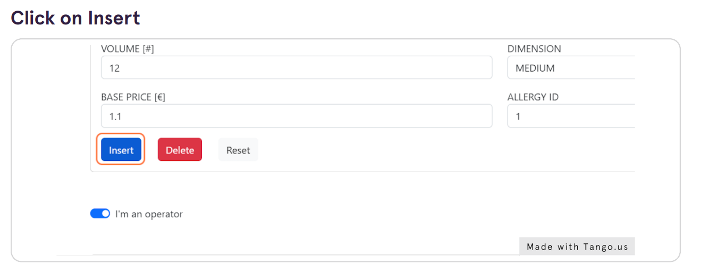

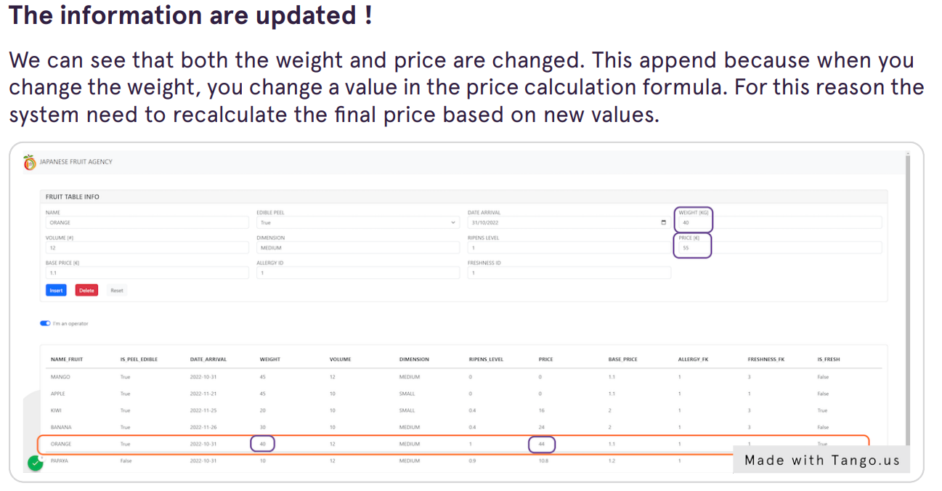

### DELETE Operation

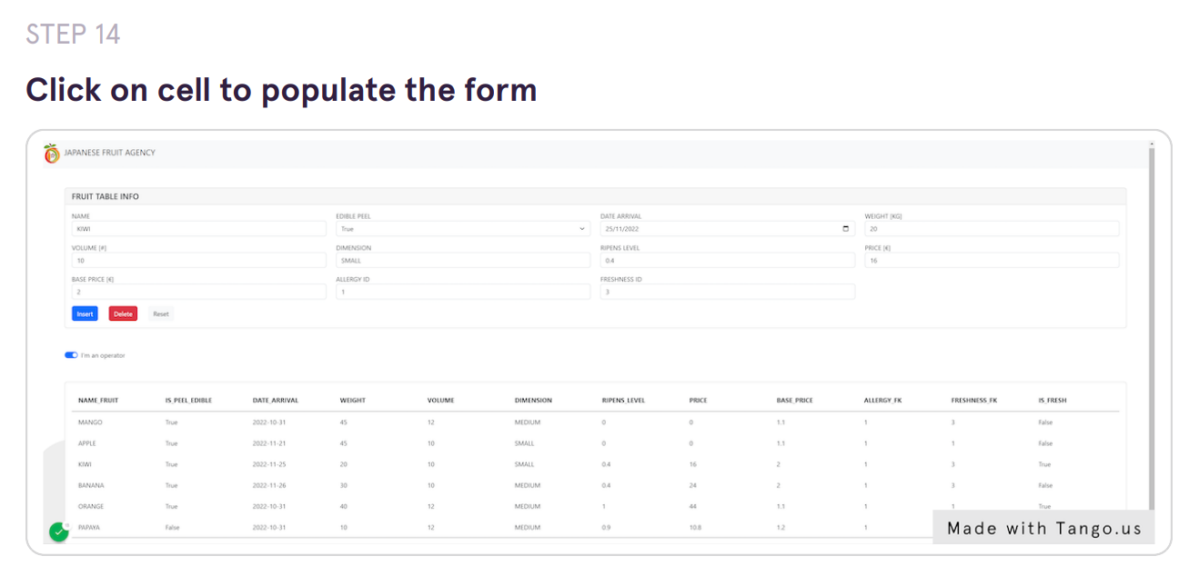

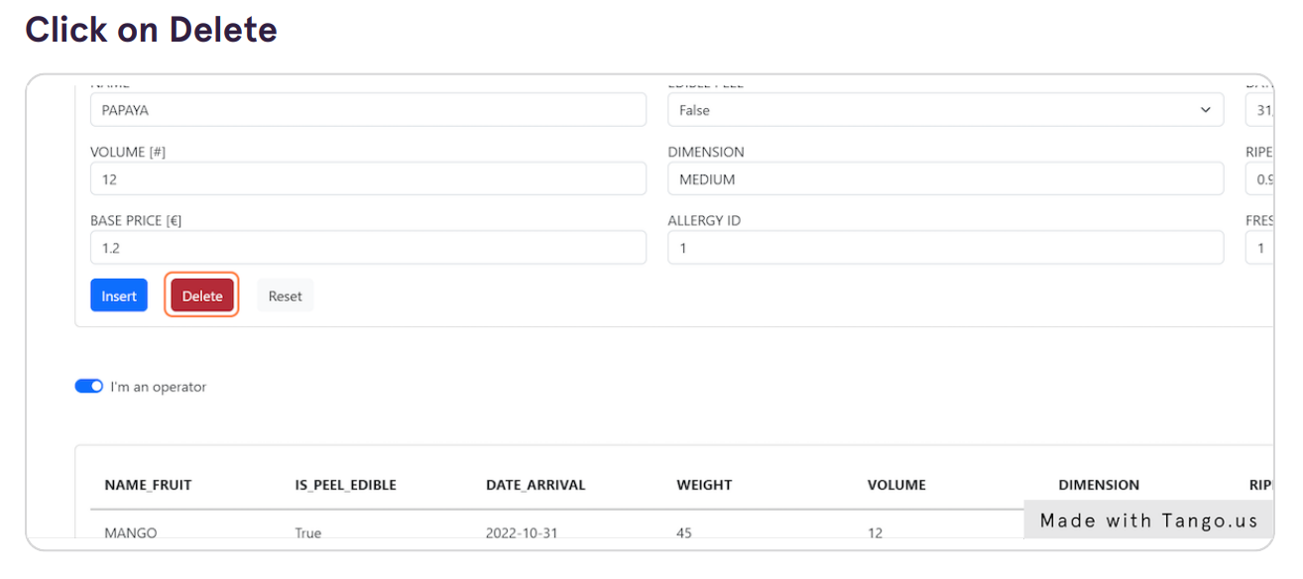

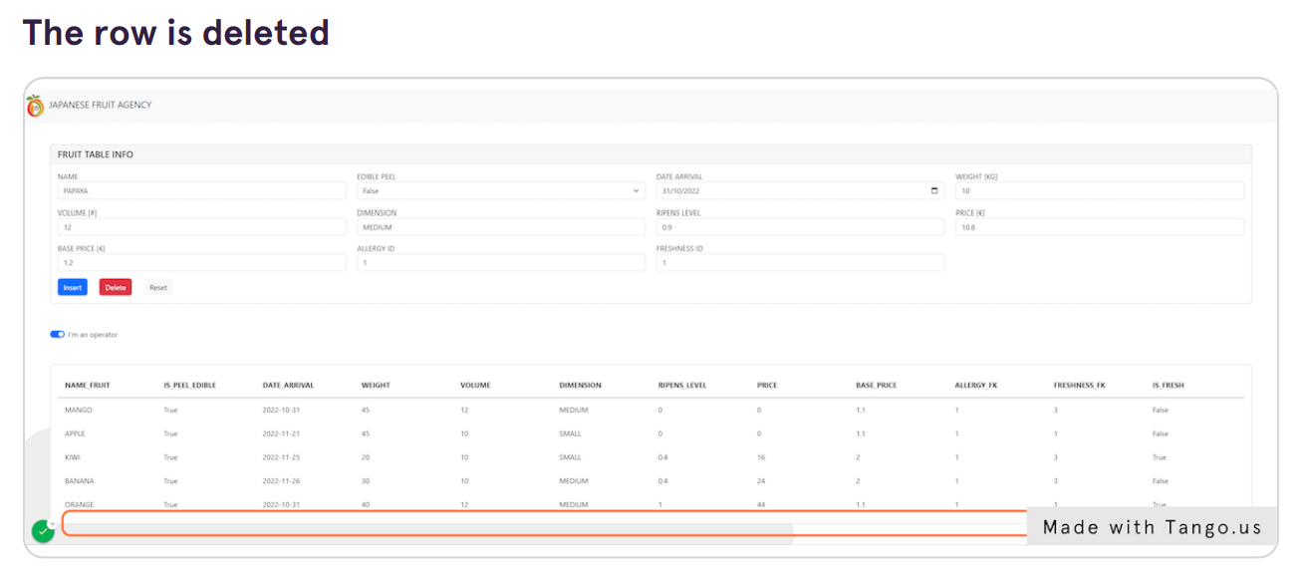

### Switch to customer view

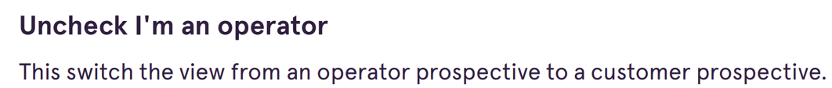

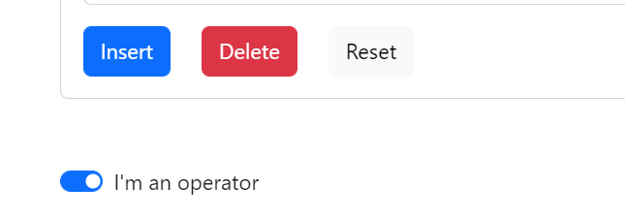

The result is:



The customer can see only fresh fruit and can’t insert or delete anything from fruit table.

## OFFER Operations

### INSERT Operation

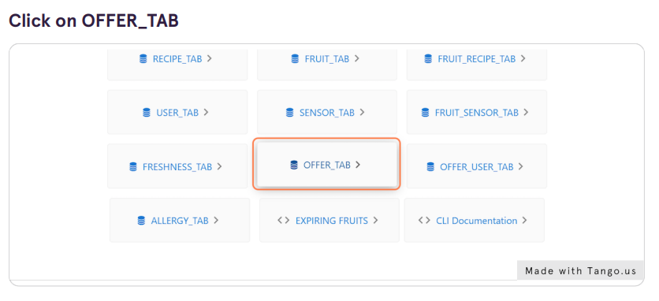

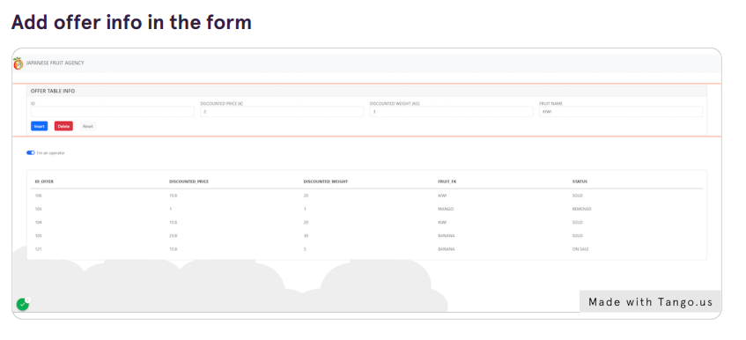

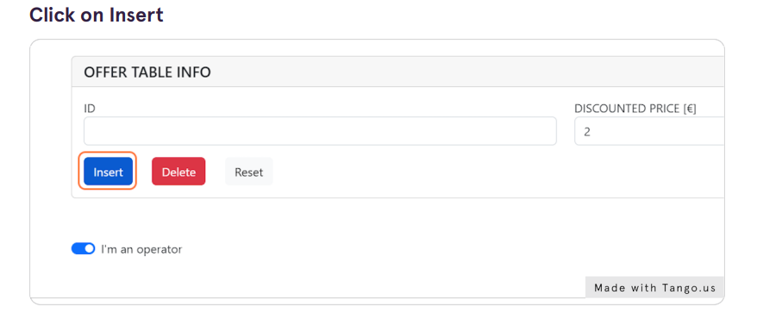

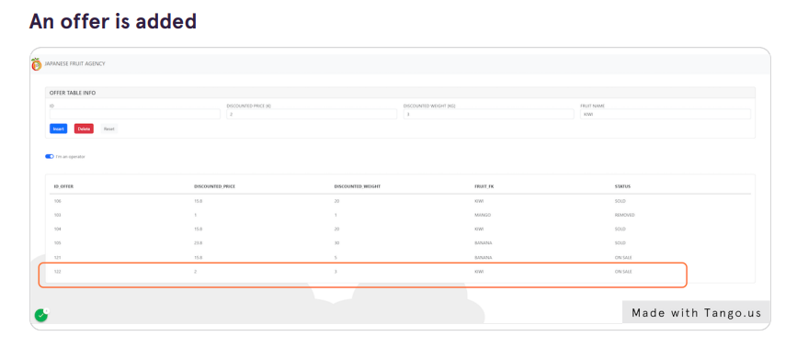

### Switch to customer view

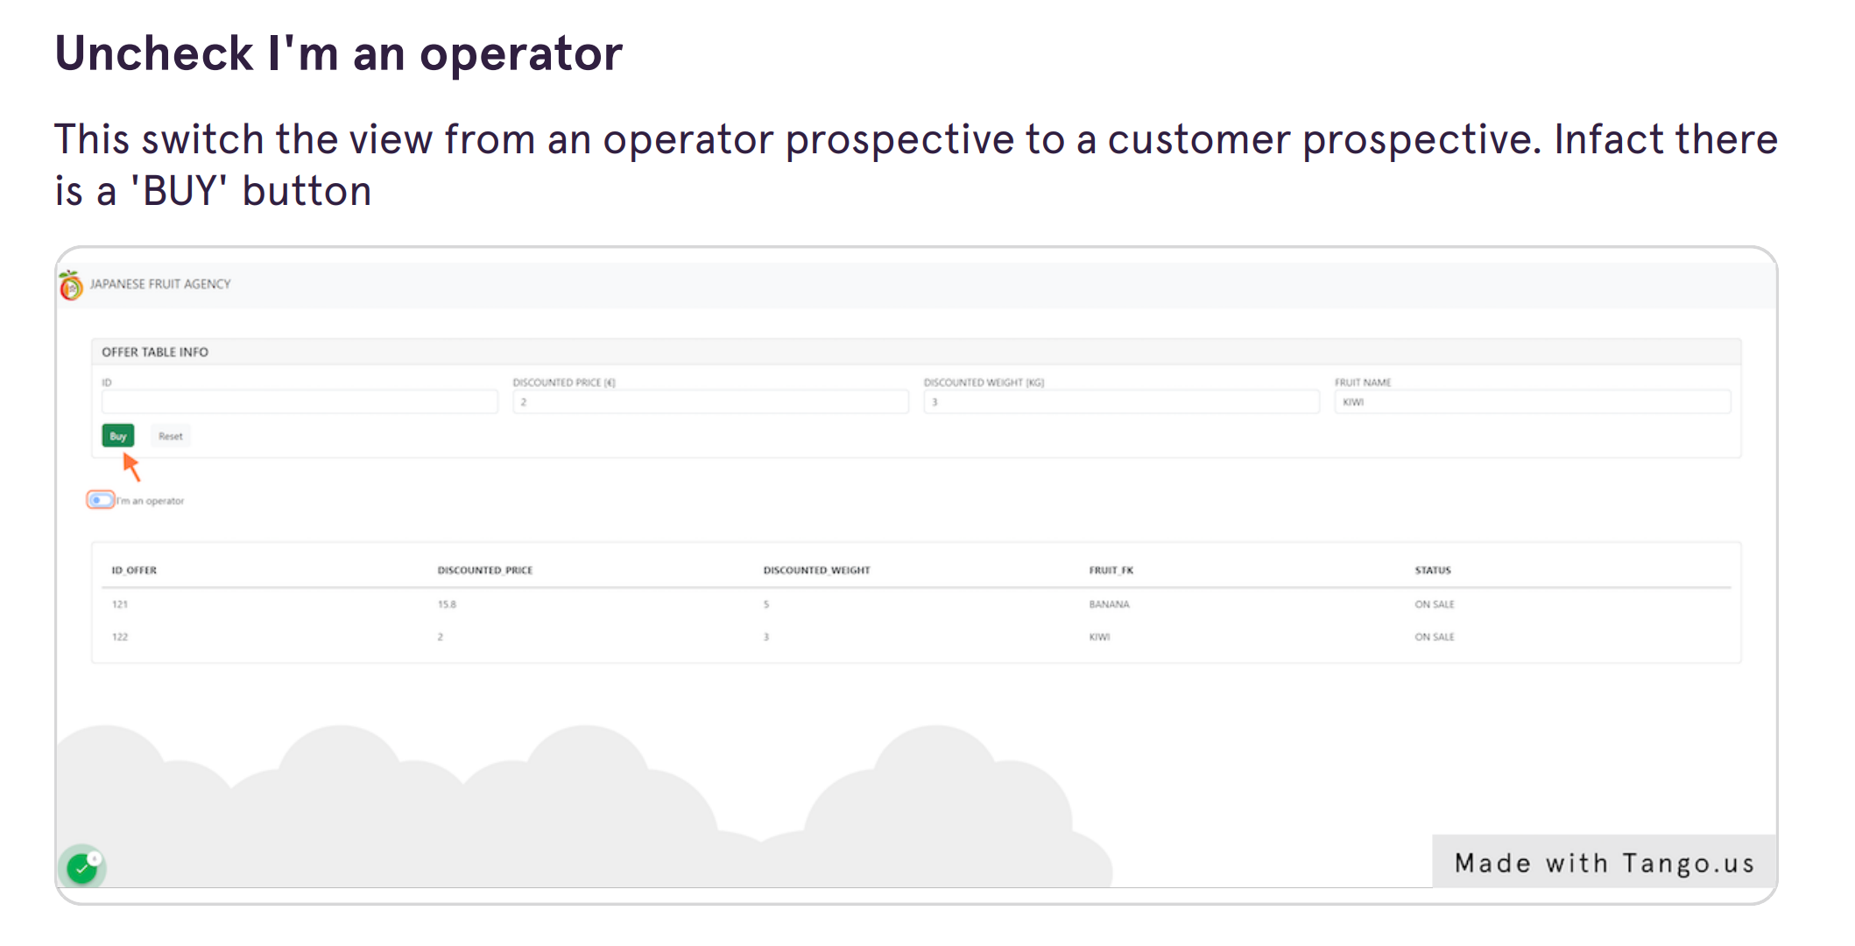

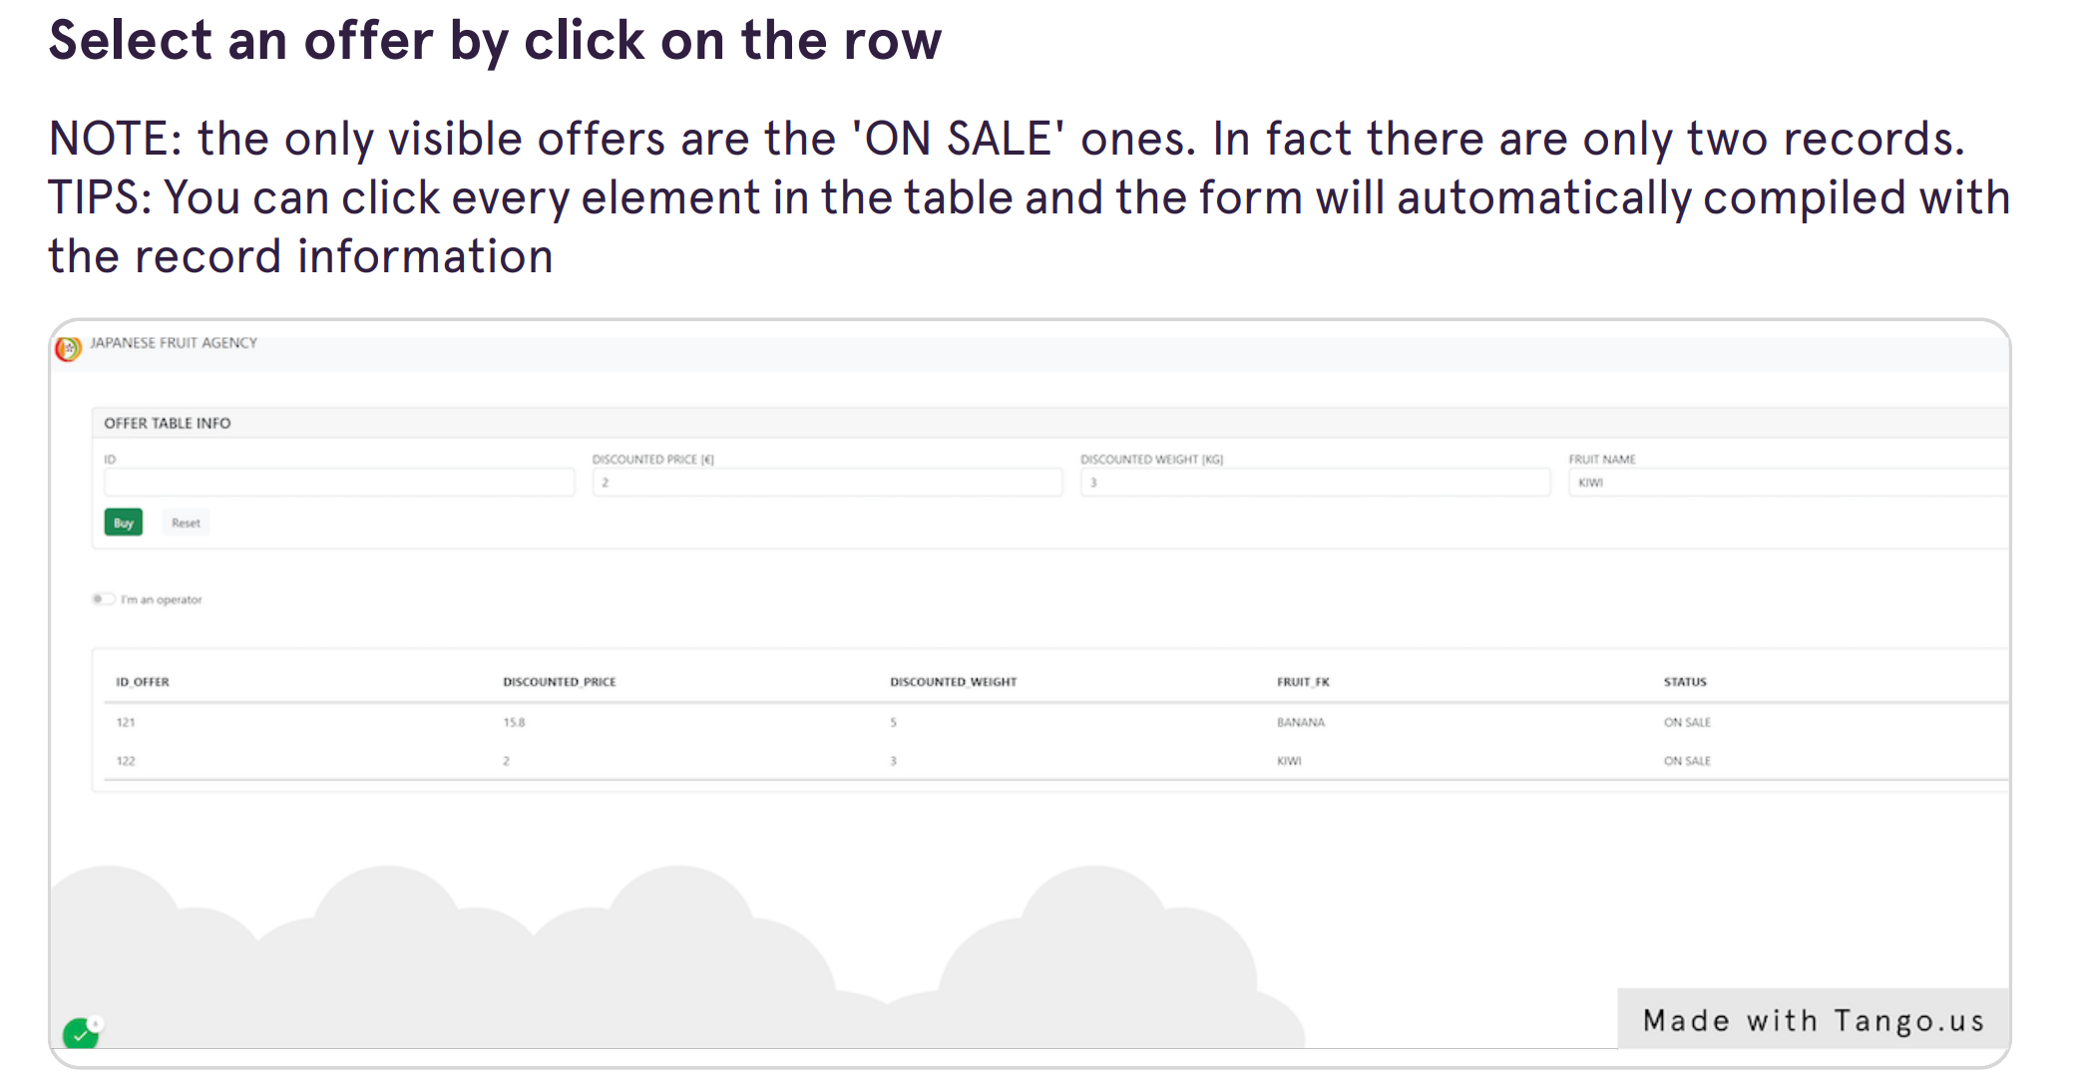

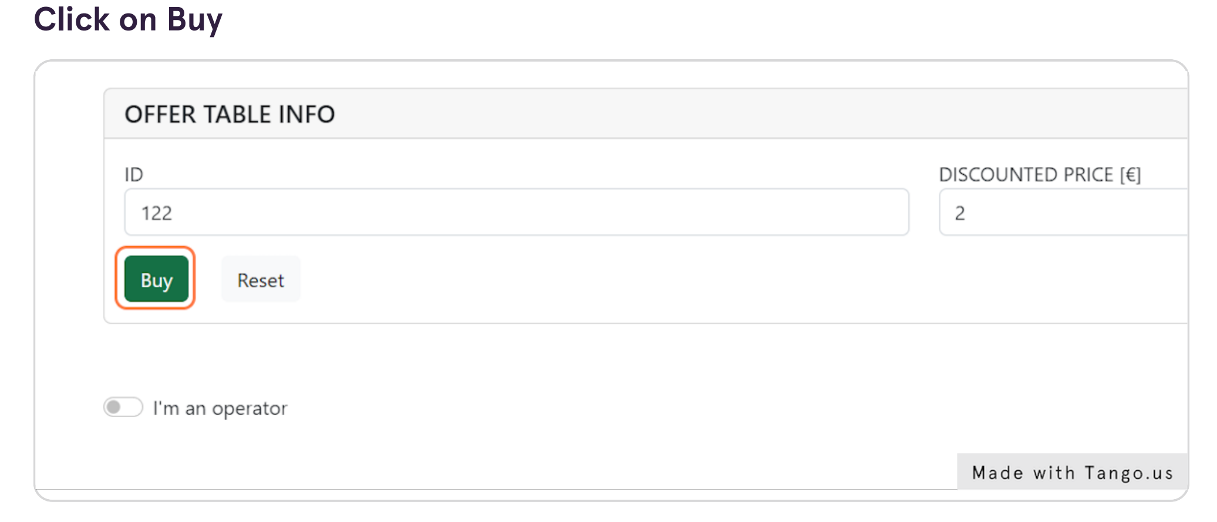

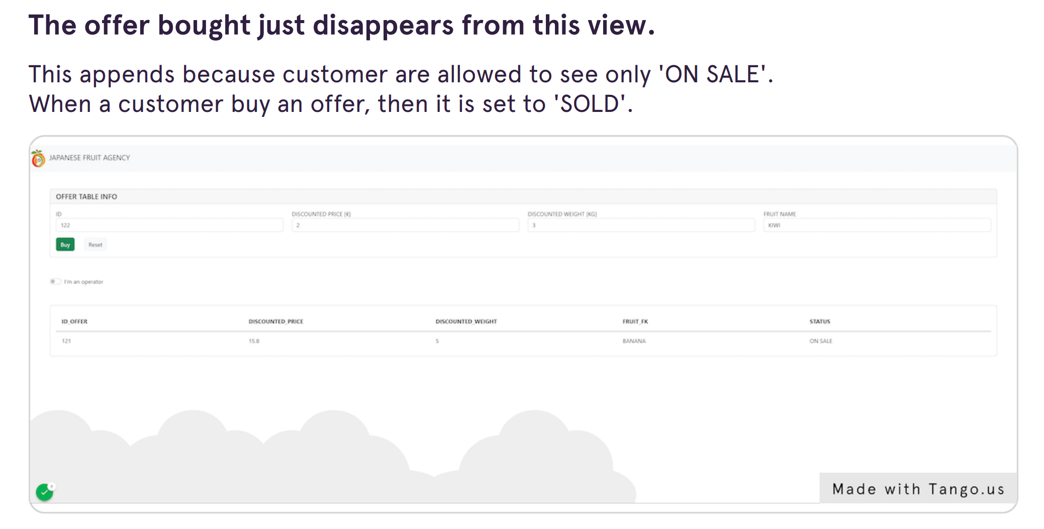

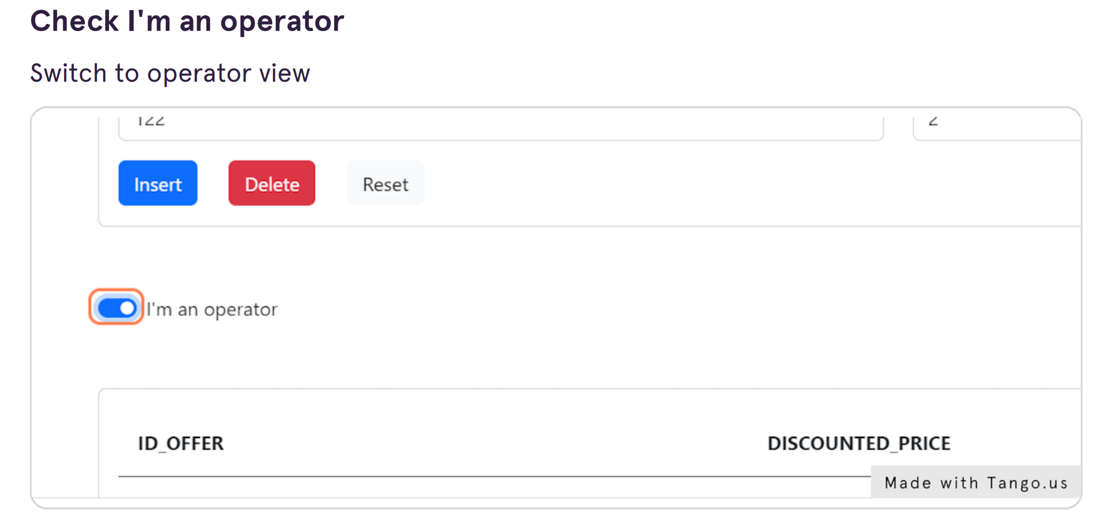

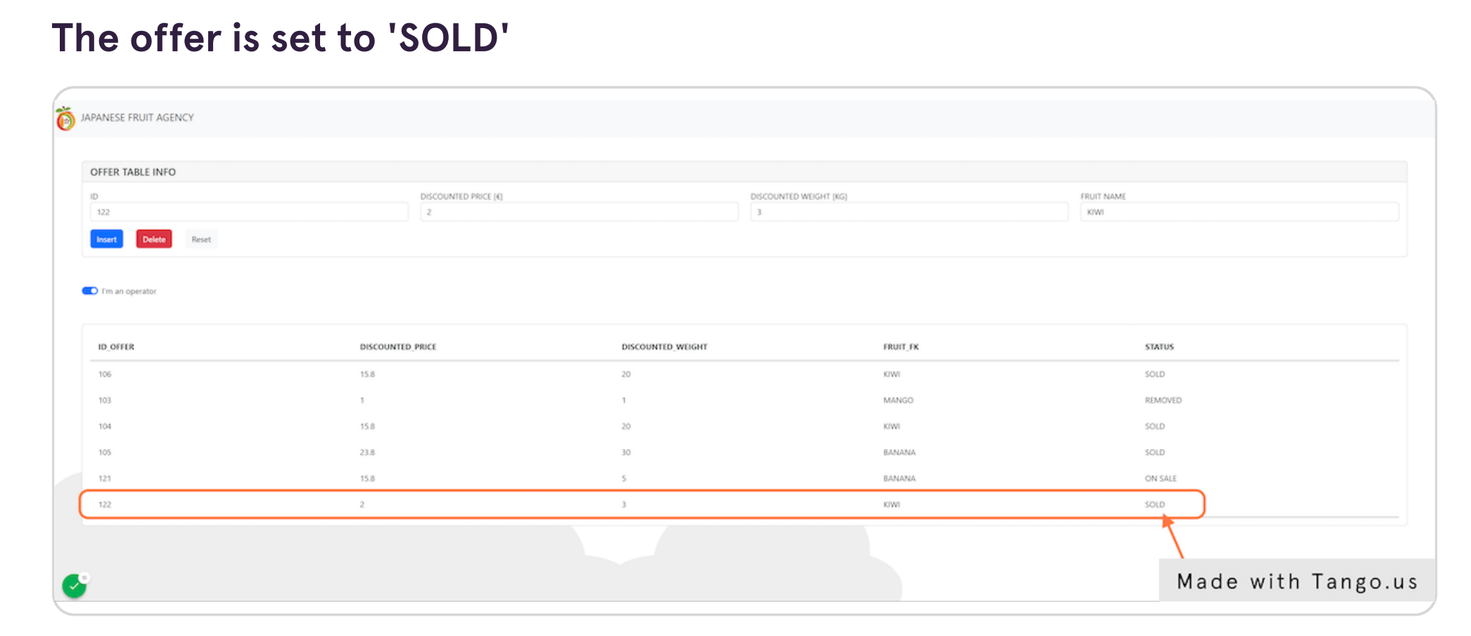

Let check the user offer table. In the user offer table all purchases are registered.

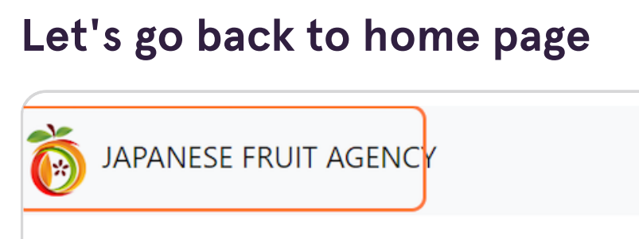

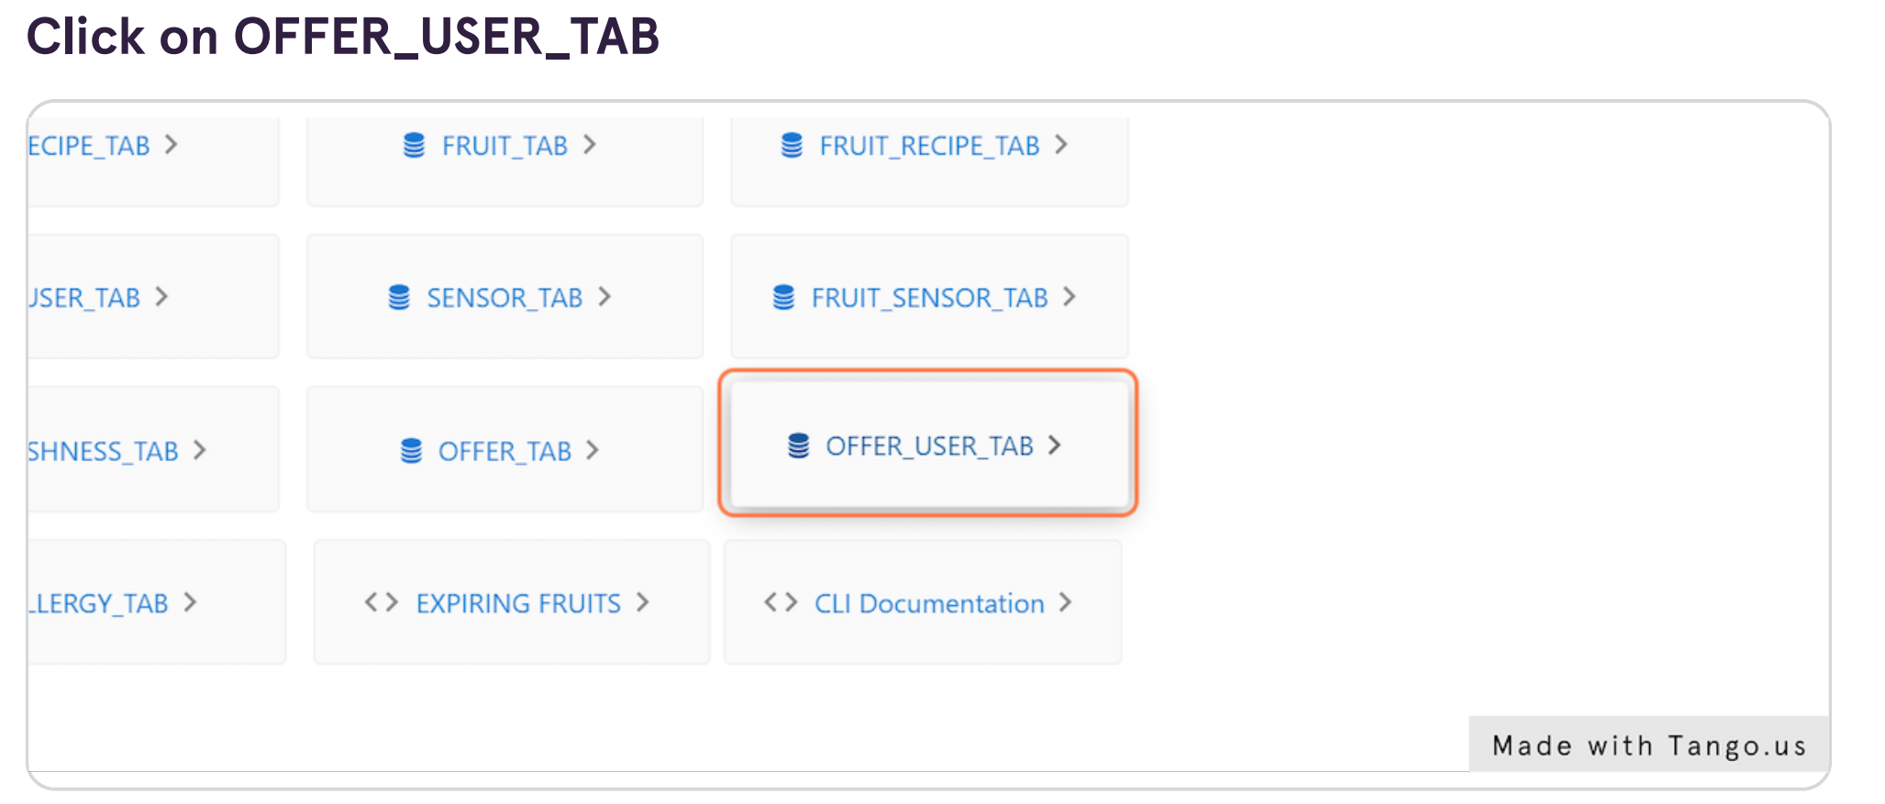

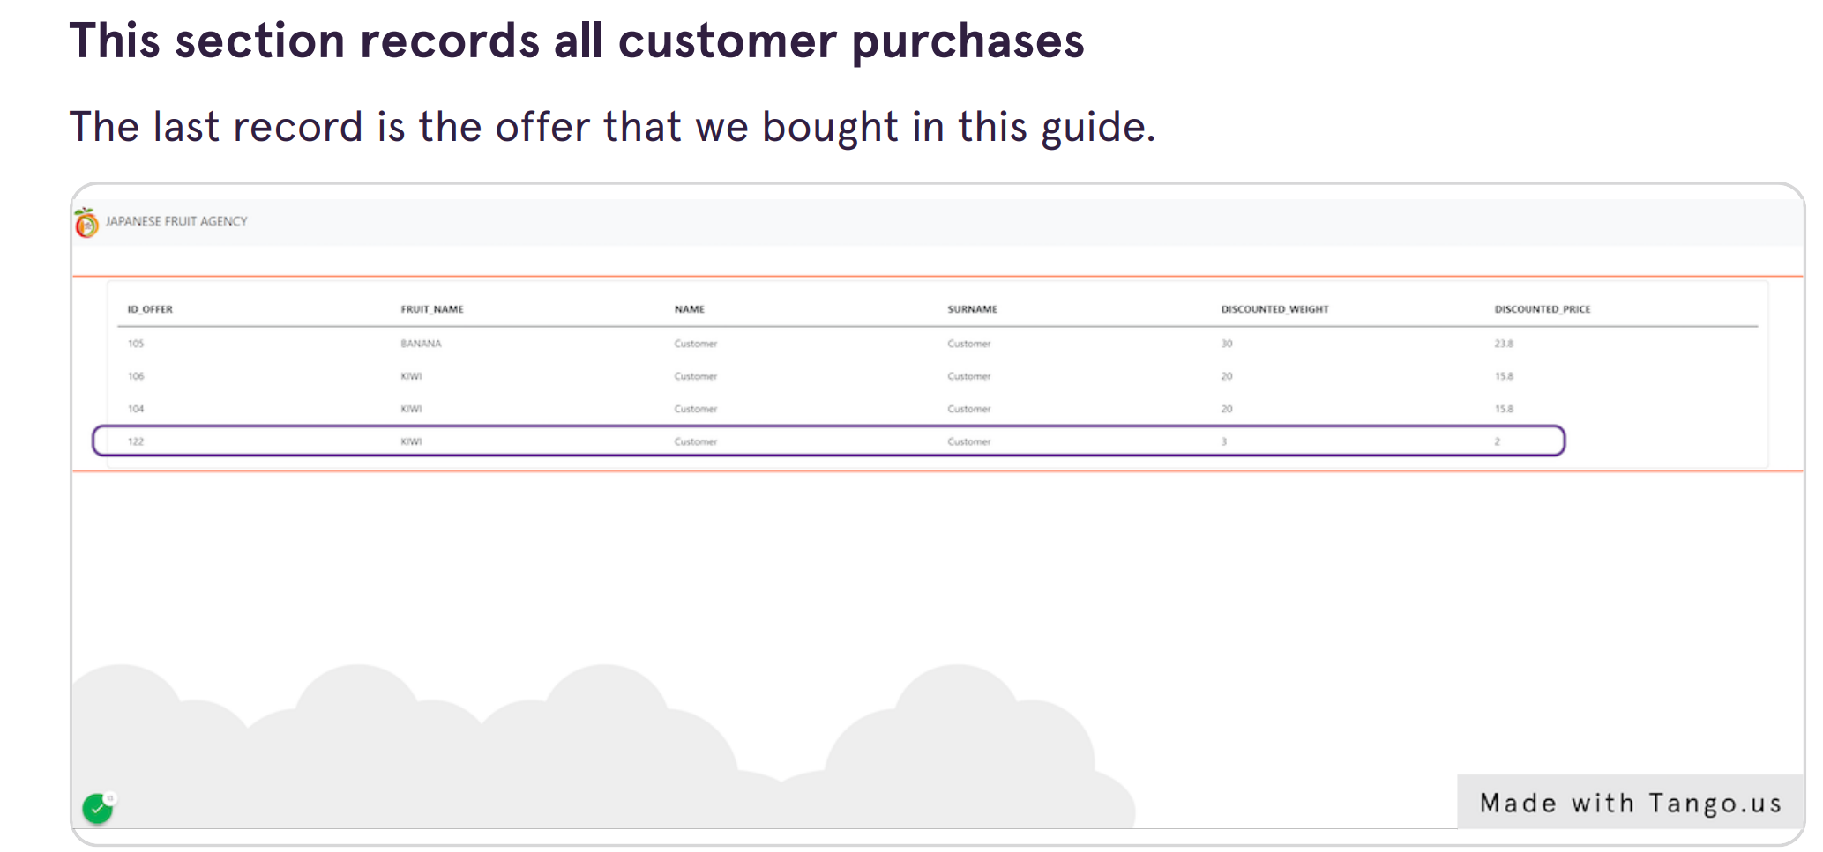

## SENSOR FRUIT Operations

We use three fruits:

|  |  |
| --- | --- |
| FRUIT | DIMENSION |
| apple | small |
| banana | medium |
| watermelon | big |

and three sensors

|  |  |
| --- | --- |
| SENSOR | DIMENSION |
| sensor 1 | small |
| sensor 2 | medium |
| sensor 3 | big |

There is a trigger that avoid assignment between a sensor and a bigger dimension fruit.

So, each sensor could scan equal size fruits or smaller ones.

We try each combination and we expect this result:

|  |  |
| --- | --- |
| SENSOR | FRUIT |
| sensor 1 | apple |
| sensor 2 | Apple, banana |
| sensor 3 | Apple, banana, watermelon |

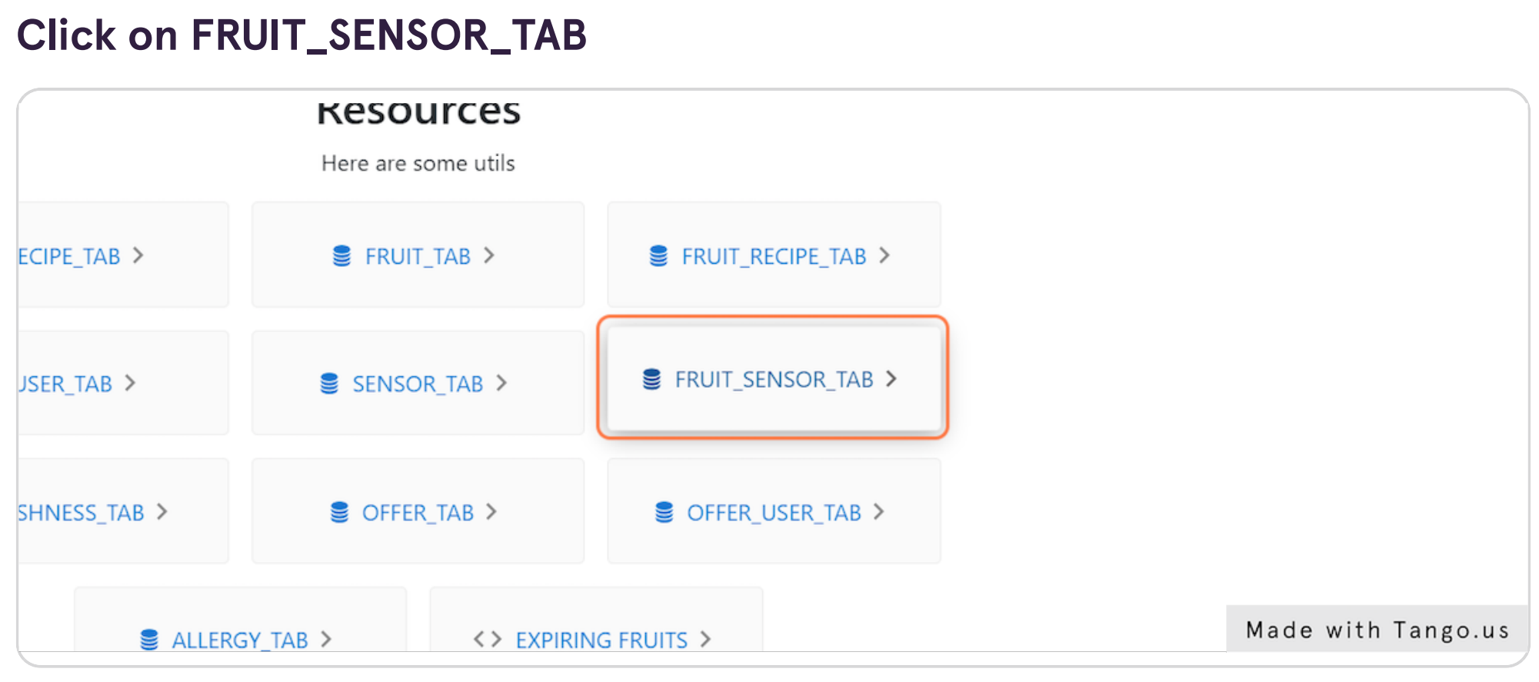

The first combination is APPLE (small) – SENSOR 1 (small)

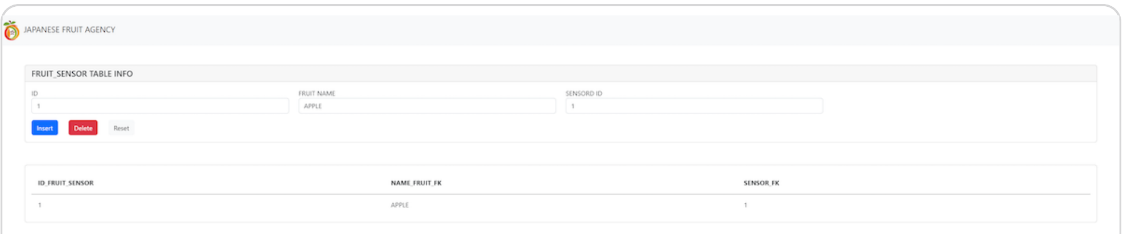

We can see that an entry is added, so this combination is correct.

Now the combination is APPLE (small) – SENSOR 2 (medium)

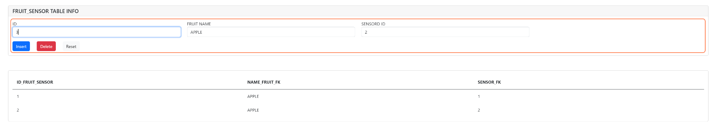

We can see that an entry is added, so this combination is correct.

The last combination is APPLE (small) – SENSOR 3 (big)

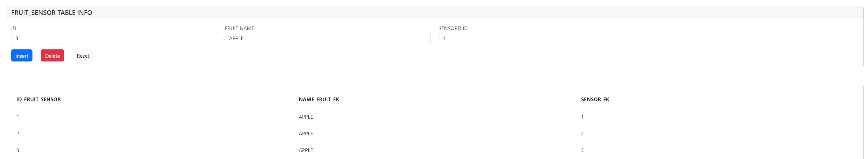

We can see that an entry is added, so this combination is correct.

Let’s try with different fruit and different dimension

Now the combination is BANANA (medium) – SENSOR 1(small)

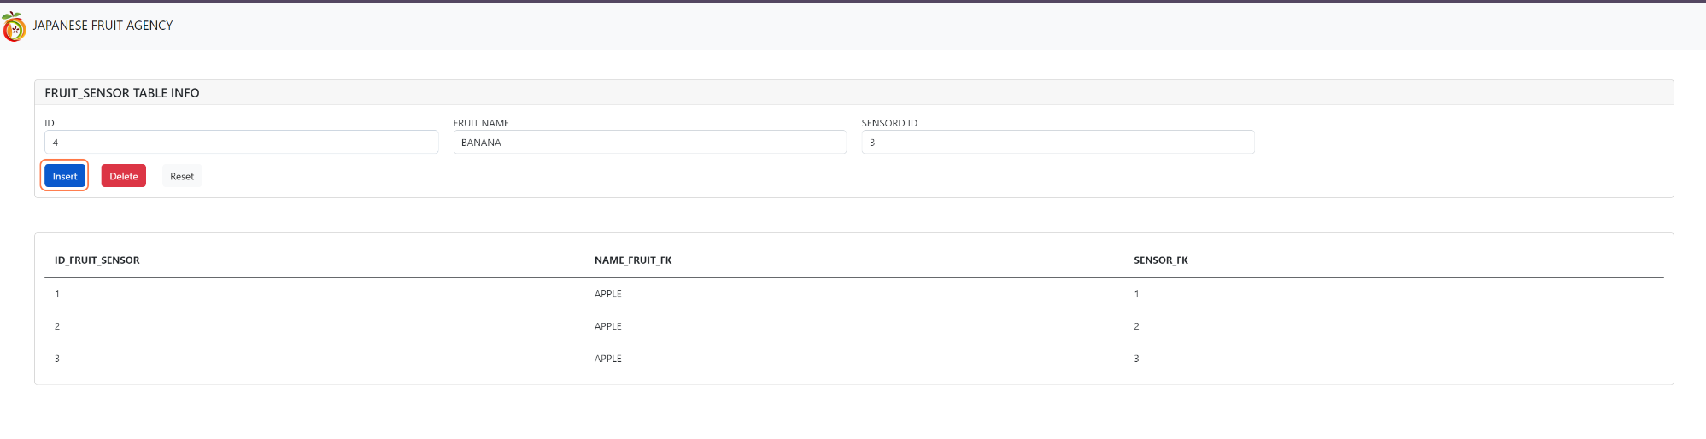

We can see that after the trigger avoid this combination because it is not correct and abort the transaction.

While with SENSOR 2 (medium) and SENSOR 3(big) there is an insert on the table because they are both a valid combination of fruit – sensor.

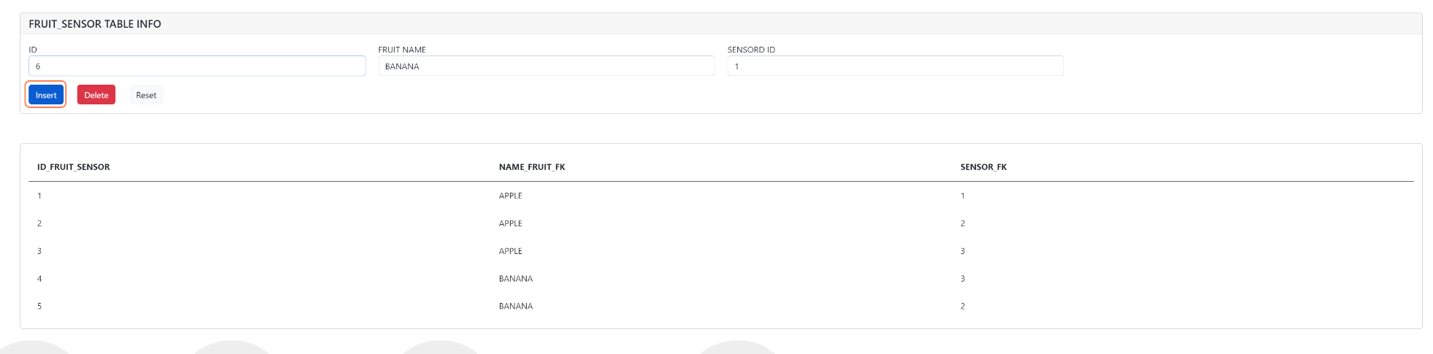

The final scenario is with the WATERMELON (BIG)

The only insert allowed is WATERMELON (big) – SENSOR 3 (big)

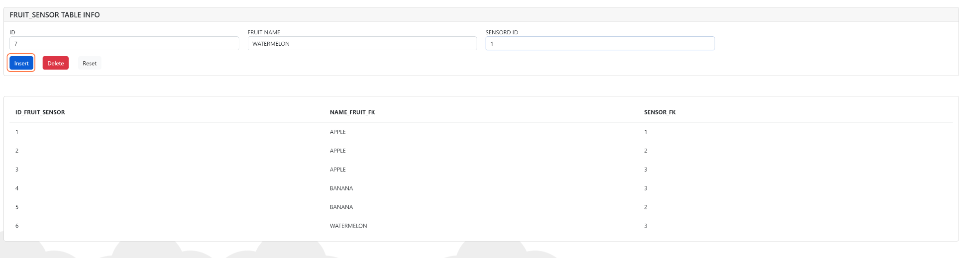

While the combination

* WATERMELON (big) – SENSOR 2 (medium) and
* WATERMELON (big) – SENSOR 1 (small)

are both aborted.

# Jobs

## Freshness check job

Today is 27/11/2022

When the job freshness check job is executed, all fruits with arrival date added to the number of freshness days are set to be not fresh.

Date arrival + days of freshness < today’s date 🡪 NOT FRESH

We take into account only fresh fruits and we check this condition.



We can say that the only fruit not fresh today is the pear with arrival date 23/11/2022 and 1 day of freshness.

After the execution of the job the last row should be not fresh. Note that the operator can’t modify the freshness value because it is calculated.



And the result is correct.

## Daily Refill Job

Increase the weight of all fruit of 30 kg

BEFORE JOB

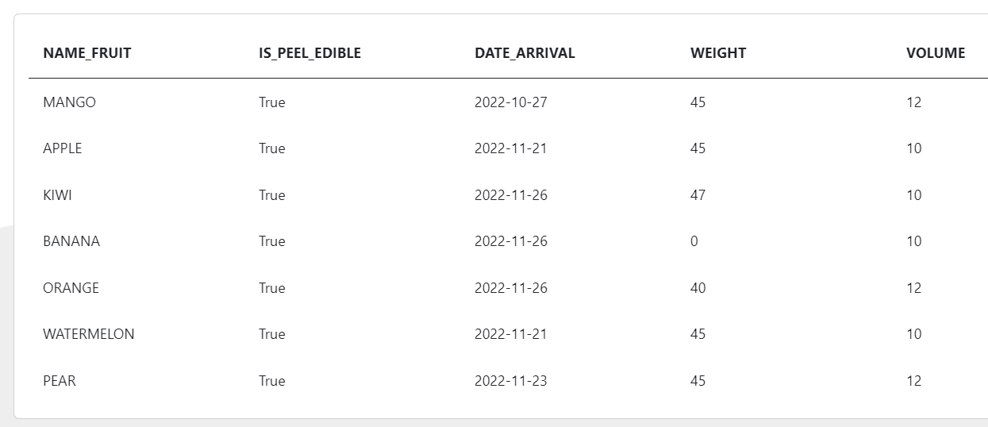

AFTER JOB

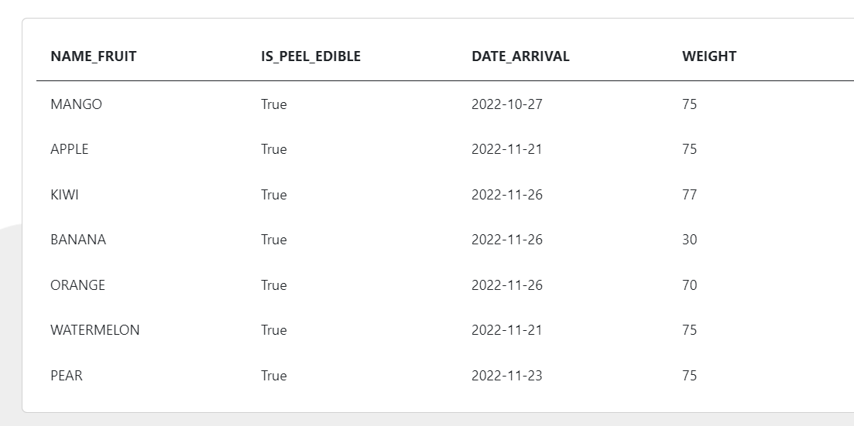

## Freshness Decay Job

This job decreases the ripens level of each fruit of 0.1. This is helpful to simulate the natural fruit process during the days.

BEFORE JOB

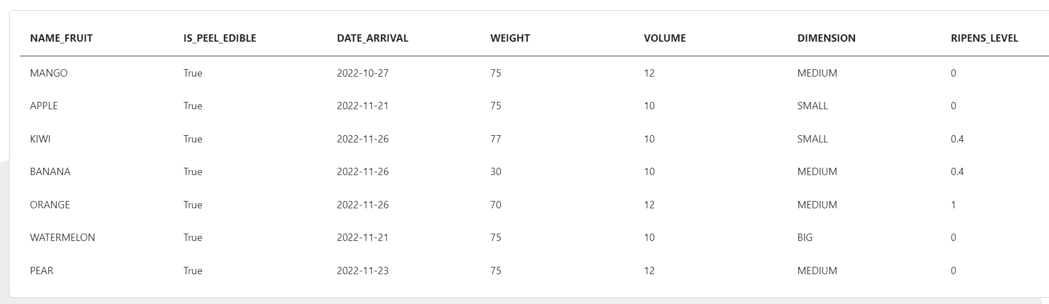

AFTER JOB

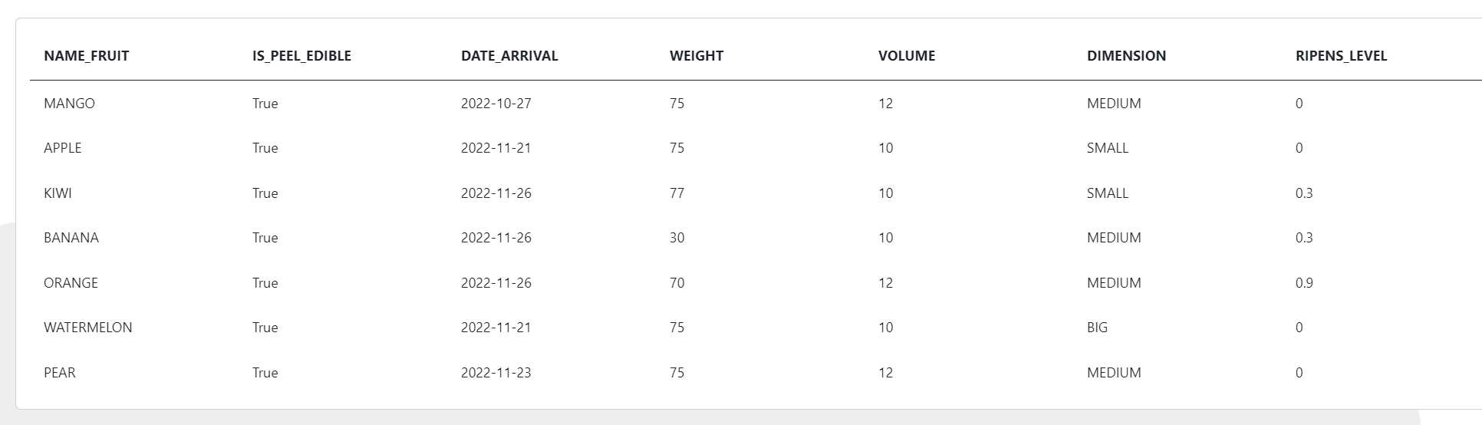

Of course, if the ripens level is already 0, the ripens level does not undergo changes.

## Offer low ripens level job

The objective of this job is to simulate the creation of an offer when the level of ripeness of a fruit is very low. Of course, all the fruit weight in the system is involved in the offer. In this way the aim is to sell the entire stock of ripe fruit as soon as possible. To do that every time this procedure is execute, the discounted price of the fruit is decreased by 0.20€.

Finally, when this job finds a fruit with ripens level 0, then all the offers on that fruit are set to ‘REMOVED’ and customer are no longer able to see those offers.

The threshold of the ripens level used for establish if a fruit is valid for an offer is 0.4.

If a fruit has this ripens level or less, then there will be an offer on all the stock of that fruit with a discounted price.

BEFORE JOB

Kiwi and banana are valid fruit for this job with their ripens levels equal to 0.3



Let’s check If there are some offer ‘ON SALE’ on those fruits before the job. 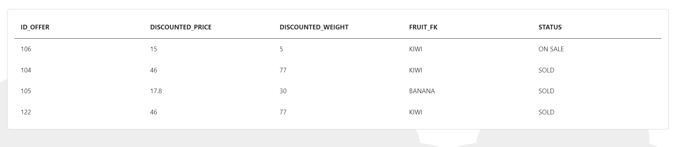

We can see that the fruit BANANA has no active offer. While kiwi has an old offer of 5 kg. Furthermore

The BANANA is no longer fresh so it is excluded.



AFTER JOB

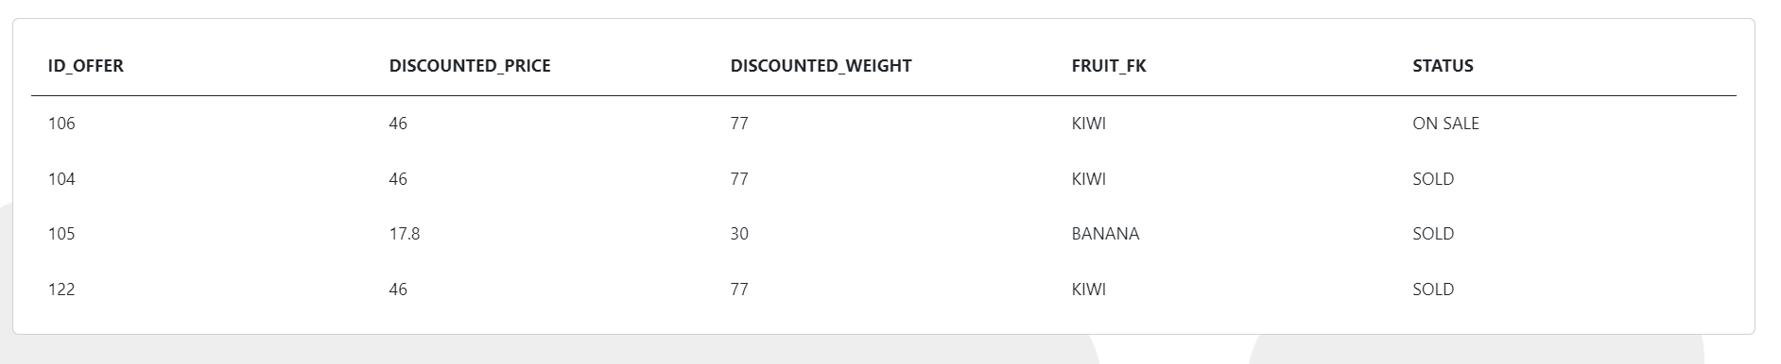

The kiwi offer is update and all the stock is now on sale with a new discounted price.

# Run application

In order to run the application, the following steps must be followed:

Download the code from [repo](https://github.com/Francesco-Ranieri/database_system):



If you want, you can create a virtual env using conda

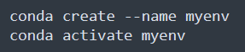

Then install the requirements.txt

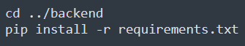

And now start docker for oracle database

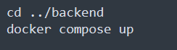

Start the backend

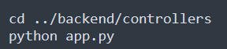

And start the frontend

